Priya Sharma 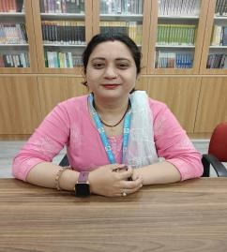

Assistant Professor
Nimbus Academy of Management Area Primary area :
Human Resource Management Secondary Area :
Organizational Behaviour

Contact
Email :
Priyasharma31659@gmail.co m Phone : 9027866411 Education
Pursing Doctoral Program (PHD) in Commerce , Manglayatan University Aligarh .
Master of Commerce, Swami Vivekananda Subharti University Meerut
BBA, Maharshi Dayananda University Rohtak
Bachelor of Education, Maharshi Dayananda University Rohtak

Teaching
Human Resource Management
Organizational Behavior

Research Area
Human Resource Management Organizational Behaviour

Academic Experience
Faculty Member ,SRS Institute of Education and Technology Meerut,
December 2018 onwards
Faculty Member, Nimbus Academy of Management Dehradun ,November 2022 Onwards
Professional Experience
School of Management

Seminars and Conferences
Attended National Seminars on Quality of Teaching in December (2014) by
V.B Convent college of Edcation
Attended National Seminar on How to write a Research Proposal in December (2023) by Nimbus Academy of Management as a organizing member
Attended National Seminar on Personality and Personal Grooming in March (2024) by Shree Sushila Devi Institute of Advanced Studies.

